**Exercise 1:**

Given the following HR database diagram, Let’s write SQL statements to define these tables with all necessary integrity constraints (e.g. primary keys, foreign keys, domain contrains, etc)

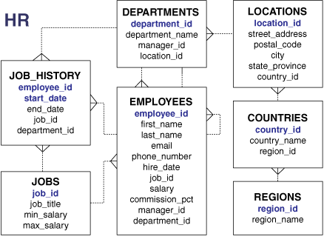

**Exercise 2:**

Write SQL statements for the following duties:

1. Display the first_name, last_name of employees that work in departments located in “Hanoi”, ordered by last_name in ascending order.
2. Create a query to display all the data from the Employees table.
3. Create a query to display the department number, department name, and manager number. Name the last column (manager number) heading as “MNG” (Employees table).
4. Create a query to display the unique combination of values in department_id and job_id columns (Employees table).
5. Display last_name, first_name of the employees that have the minimum salary w.r.t. a specific job title.

STRING FUNCTION

1. How many employees whose last_name ends with “NH”.
2. Display the last_name land the length of the last name for all employees where last name’s length is greater than 8 characters.
3. For all employees, display the last_name, and username. The username will be composed from the first letter of first name concatenated with three last letters of last name concatenated with the string “2019”. (e.g. Trung Tran -> TTRA2019)
4. Create a query to display the last name concatenated with the first name, separated by space, and the telephone number concatenated with the email address, separated by hyphen. Name the column headings “FULL_NAME” and “CONTACT_DETAILS” respectively (Employees tables).

NULL-RELATED FUNCTIONS

1. Display the first name, last name, phone number of all employees. Replace every null value in phone number with ‘N/A’.

DATE FUNCTIONS

1. Display last name and first name of employees where the hired date is in “June”
2. Display all the employees that were hired in the last 5 years.

CASE FUNCTIONS

1. Display employee salary and a column “comment” whose value is set as follow:
   1. If salary >= 5000, comment = ‘Very high’
   2. If salary >= 3000 and salary < 5000, comment =’Hight’
   3. If salary < 300, comment = ‘low’

WHERE CLAUSE

1. Display the employee number, first name, job id and department number for all employees whose department number is not equal to 20, 60 and 80 (Employees table).
2. Display all data from Employees table for all employees whose: salary is in the range of 6000 and 800 and their commission is not null

or

department number is not equal to 80, 90 and 100 and their hire date is before January 1st, 1990.

JOIN CLAUSE

1. For each department, display the department name, city, and state province.
2. For each employee, display the last name, and the manager’s last name.
3. Display the last name and salary for all employees who earn less than employee number 103.

AGGREGATE FUNCTIONS

1. Display total number of employees for department_id = D122
2. Display average salary for job_id = J3224

GROUP BY CLAUSE

1. Display total number of employees for every departments.
2. Display total number of employees for every departments located in “Hanoi”.
3. Display average salary for every departments that the total number of employees equal to 50.
4. Display the countries have more than 30 departments.
5. Display the countries have both departments “ZARA” and “H&M”.
6. Display the countries have departments “ZARA” or “H&M”.

MISCELLANEOUS

1. Display the first name, salary, and department number for all employees who earn more than the minimum salary in department number 60 (Employees table).
2. Display the first name, salary, and department number for all employees who earn less than the average salary, and also work at the same department as employee whose first name is Kevin.
3. Display the countries that have no department “ZARA”.
4. Display any country that has the greatest number of departments